**Testing Work Rules**

Resources 2

Earliest Start Time 2

Latest End Time Warning and Alert 3

Meal Overdue – Non-Minor 4

Meal Overdue –Minor 5

Shift Length Maximum Warning and Alert 5

Shift Length Maximum Warning and Alert - Minor 6

Shift Length Minimum 7

Shift Length Minimum - Minor 8

Short Meal - Minor 8

Short Meal - Minor 9

Confirm Availability 9

Early In 9

Incomplete Forms 10

Late In 10

No Punch for Scheduled Shift 11

Meal Scheduled 11

Not Scheduled to Work 12

Shift End 12

Work Rules – Testing

# Resources

Testing work rules requires store numbers to be set up in QA, employees (at least 2) to be assigned to each store number, POS devices to be set up in QA iPOS lab, and the work rules need to be configured for each store’s requirements.

## Store Information

Store IDs need to be set up for new stores where work rules are to be tested.

## Peoplesoft

At least 2 employee IDs need to be assigned to the store to be work rule tested. The employees ideally would have a ROLE_EM = ‘02’ and ID_WRK_GP = ‘16’

## iPOS

The iPOS lab should have registers set up with functioning receipt printers. Also, the work rules should be configured individually for each store based on the work rule requirements developed by the business.

# Earliest Start Time

The earliest time an employee can clock in (minor)

## Verification: Central Office

SELECT ANF_DC_CNCT FROM PA_EM WHERE ID_EM = 'employee ID' and ID_STR_RT = 'store ID'

Verify ANF_DC_CNCT has DOB that makes the employee a minor (usually 17 or under)

## Set up: Central Office

UPDATE ANF_PARAMETER SET PARAM_VALUE = ’14:00’ WHERE SUB_CATEGORY = 'MINOR_EARLIEST_START_TIME' and PARAM_NAME = 'EarliestStartTime' and PARAM_LEVEL_ID = 'COUNTRY' and PARAM_LEVEL_VALUE = ‘country code’

UPDATE ANF_PARAMETER SET PARAM_VALUE = ‘True’ WHERE SUB_CATEGORY = 'MINOR_EARLIEST_START_TIME'and PARAM_NAME = 'Enabled' and PARAM_LEVEL_ID = 'COUNTRY' and PARAM_LEVEL_VALUE = 'country code'

## Execution:

Attempt to clock the minor employee in prior to the Earliest Start Time set up in field: PARAM_VALUE in table: ANF_PARAMETER

**Expected Result**: Display Message screen displays following message:

**‘MESSAGE‘**

# Latest End Time Warning and Alert

The latest time an employee can clock out (minor)

## Verification: Central Office

SELECT ANF_DC_CNCT FROM PA_EM WHERE ID_EM = 'employee ID' and ID_STR_RT = 'store ID'

Verify ANF_DC_CNCT has DOB that makes the employee a minor (usually 17 or under)

SELECT * FROM ANF_PARAMETER WHERE SUB_CATEGORY = 'MINOR_LATEST_END_TIME_WARNING' and PARAM_NAME = 'LatestEndTimeWarningMinutes'

Verify PARAM_VALUE is set to ‘15’

## Set up: Central Office

UPDATE ANF_PARAMETER SET PARAM_VALUE = ’21:00’ WHERE SUB_CATEGORY = 'MINOR_LATEST_END_TIME' and PARAM_NAME = 'LatestEndTime' and PARAM_LEVEL_ID = 'COUNTRY' and PARAM_LEVEL_VALUE = 'country code'

UPDATE ANF_PARAMETER SET PARMA_VALUE = ‘True’ WHERE SUB_CATEGORY = 'MINOR_LATEST_END_TIME' and PARAM_NAME = 'Enabled' and PARAM_LEVEL_ID = 'COUNTRY' and PARAM_LEVEL_VALUE = 'country code'

UPDATE ANF_PARAMETER SET PARAM_VALUE = ‘True’ WHERE SUB_CATEGORY = 'MINOR_LATEST_END_TIME_WARNING' and PARAM_NAME = 'Enabled' and PARAM_LEVEL_ID = 'COUNTRY' and PARAM_LEVEL_VALUE = 'country code'

## Execution:

Clock the minor employee in at least 45 – 30 minutes prior to the value set up for Latest End Time

15 minutes prior to the Latest End Time, the Latest End Time Warning should fire (The command runs every 5 minutes so it should go off at least 10 minutes prior to the alert)

**Expected Result**: Display Message screen displays following message:

**‘MESSAGE‘**

At the time of the Latest End Time or after, the alert fires

**Expected Result**: Display Message screen displays following message:

**‘**Subject: Latest Time Violation

Message: Labor law requires that minors cannot work past 21:00. Manager acknowledgement is required to ensure that Kohei Sato will punch out immediately to minimize any work violation‘

# Meal Overdue – Non-Minor

An employee has a scheduled meal break, the employee is done with 70% of their shift, and they have still not punched out for their break

## Verification: Central Office

SELECT ANF_DC_CNCT FROM PA_EM WHERE ID_EM = 'employee ID' and ID_STR_RT = 'store ID'

Verify ANF_DC_CNCT has DOB that makes the employee not a minor (usually 18 or over)

## Set up: Central Office

INSERT INTO "ANF_SCHEDULE_SHIFT"("ID_EM","ID_STR_RT","WEEK_END_DATE", "DAY_OF_WEEK", "SHIFT_NUMBER", "SHIFT_START_TIME", "SHIFT_END_TIME", "BREAK_START_TIME", "BREAK_END_TIME", "DELETED_TIME", "CREATED_TIME", "LAST_UPDATED_ID", "LAST_UPDATED_TIME", "SHIFT_TYPE") VALUES('employee ID', 'country code', '2011-03-12 00:00:00.00','3','25432','2011-03-08 09:45:00.00','2011-03-08 14:00:00.00','2011-03-12 10:30:00.00','2011-03-12 11:00:00.00', null, current_timestamp, 'peeps', current_timestamp, 'R');

**Note**: you can make the shift start time for a time in the past and just adjust the clock punch time in the local DB after you punch the employee in

## Set up: Regional’s

DELETE * FROM ANF_CLOCK_PUNCH WHERE ID_EM = ‘employee ID’ and ID_STR_RT = ‘store ID’

## Set up: H2 Database

After clocking in the employee:

SELECT * FROM ANF_CLOCK_PUNCH WHERE ID_EM = ‘employee ID’

Change the employee punch in time to correspond with the shift start time and restart iPOS

## Execution:

Calculate when 70% of the shift has occurred, alert should fire

**Expected Result**: Display Message screen displays following message:

**‘MESSAGE’**

# Meal Overdue –Minor

A minor associate has a scheduled meal break, the employee is done with 70% of their shift, and they have still not punched out for their break

## Verification: Central Office

SELECT ANF_DC_CNCT FROM PA_EM WHERE ID_EM = 'employee ID' and ID_STR_RT = 'store ID'

Verify ANF_DC_CNCT has DOB that makes the employee a minor (usually 17 or under)

## Set up: Central Office

INSERT INTO "ANF_SCHEDULE_SHIFT"("ID_EM","ID_STR_RT","WEEK_END_DATE", "DAY_OF_WEEK", "SHIFT_NUMBER", "SHIFT_START_TIME", "SHIFT_END_TIME", "BREAK_START_TIME", "BREAK_END_TIME", "DELETED_TIME", "CREATED_TIME", "LAST_UPDATED_ID", "LAST_UPDATED_TIME", "SHIFT_TYPE") VALUES('employee ID', 'country code', '2011-03-12 00:00:00.00','3','25432','2011-03-08 09:45:00.00','2011-03-08 14:00:00.00','2011-03-12 10:30:00.00','2011-03-12 11:00:00.00', null, current_timestamp, 'peeps', current_timestamp, 'R');

**Note**: you can make the shift start time for a time in the past and just adjust the clock punch time in the local DB after you punch the employee in

## Set up: Regional’s

DELETE * FROM ANF_CLOCK_PUNCH WHERE ID_EM = ‘employee ID’

## Set up: H2 Database

After clocking in the employee:

SELECT * FROM ANF_CLOCK_PUNCH WHERE ID_EM = ‘employee ID’

Change the employee punch in time to correspond with the shift start time and restart iPOS

## Execution:

Calculate when 70% of the shift has occurred, alert should fire

**Expected Result**: Display Message screen displays following message:

**‘MESSAGE’**

# Shift Length Maximum Warning and Alert

An employee has not punched out and the maximum amount of minutes allowed has been reached or exceeded.

## Verification: Central Office

SELECT ANF_DC_CNCT FROM PA_EM WHERE ID_EM = 'employee ID' and ID_STR_RT = 'store ID'

Verify ANF_DC_CNCT has DOB that makes the employee not a minor (usually 18 or over)

select * from anf_parameter where category = 'AlertRule' and sub_category = 'SHIFT_LENGTH_MAXIMUM' AND PARAM_LEVEL_VALUE = 'country code'

Identify what the shift length maximum is by what is in the PARAM_VALUE field

## Set up: Central Office

update anf_parameter set param_value = '120' where category = 'A'lertRule’ and sub_category = 'SHIFT_LENGTH_MAXIMUM' AND PARAM_LEVEL_VALUE = 'country code'

update anf_parameter set param_value = '120' where category = 'A'lertRule’ and sub_category = 'SHIFT_LENGTH_MAXIMUM_WARNING' AND PARAM_LEVEL_VALUE = 'country code'

## Set up: Regional’s

DELETE * FROM ANF_CLOCK_PUNCH WHERE ID_EM = ‘employee ID’

## Execution:

Punch the employee in on the register and then wait for 15 minutes prior to the expiration of the shift length maximum

**Expected Result**: Display Message screen displays following message:

**‘MESSAGE’**

Once the shift length maximum has expired, log an employee in through associate access

**Expected Result**: Display Message screen displays following message:

**‘**Subject: Shift Length Violation

Message: Labor law requires that associates cannot work in excess of 8 hours per day. Manager Acknowledgement is required to ensure that Kohei Sato will punch out immediately to minimize any work rule violaiton**’**

# Shift Length Maximum Warning and Alert - Minor

An employee has not punched out and the maximum amount of minutes allowed has been reached or exceeded.

## Verification: Central Office

SELECT ANF_DC_CNCT FROM PA_EM WHERE ID_EM = 'employee ID' and ID_STR_RT = 'store ID'

Verify ANF_DC_CNCT has DOB that makes the employee a minor (usually 17 or under)

select * from anf_parameter where category = 'AlertRule' and sub_category = 'SHIFT_LENGTH_MAXIMUM' AND PARAM_LEVEL_VALUE = 'country code'

Identify what the shift length maximum is by what is in the PARAM_VALUE field

## Set up: Central Office

update anf_parameter set param_value = '120' where category = 'A'lertRule’ and sub_category = 'SHIFT_LENGTH_MAXIMUM' AND PARAM_LEVEL_VALUE = 'country code'

update anf_parameter set param_value = '120' where category = 'A'lertRule’ and sub_category = 'SHIFT_LENGTH_MAXIMUM_WARNING' AND PARAM_LEVEL_VALUE = 'country code'

## Set up: Regional’s

DELETE * FROM ANF_CLOCK_PUNCH WHERE ID_EM = ‘employee ID’

## Execution:

Punch the employee in on the register and then wait for 15 minutes prior to the expiration of the shift length maximum

**Expected Result**: Display Message screen displays following message:

**‘**Subject: Shift Length Warning

Message: Labor law requires that minors cannot work in excess of 8 hours per day. Please inform a manager that Kohei Sato will need to punch out by 17:00 to avoid any work rule violation.**’**

Once the shift length maximum has expired, log an employee in through associate access

**Expected Result**: Display Message screen displays following message:

**‘**Subject: Shift Length Violation

Message: Labor law requires that minors cannot work in excess of 8 hours per day. Manager Acknowledgement is required to ensure that Kohei Sato will punch out immediately to minimize any work rule violaiton**’**

# Shift Length Minimum

An employee attempts to punch out before the minimum amount of minutes has been reached.

## Verification: Central Office

SELECT ANF_DC_CNCT FROM PA_EM WHERE ID_EM = 'employee ID' and ID_STR_RT = 'store ID'

Verify ANF_DC_CNCT has DOB that makes the employee not a minor (usually 18 or over)

## Set up: Central Office

update anf_parameter set param_value = '120' where category = 'A'lertRule’ and sub_category = 'SHIFT_LENGTH_MINIMUM' AND Param_name = ‘ShiftLengthMinimumMinutes’ AND PARAM_LEVEL_VALUE = 'country code'

## Set up: Regional’s

DELETE * FROM ANF_CLOCK_PUNCH WHERE ID_EM = ‘employee ID’

## Execution:

Punch the employee in on the register and then wait for 15 minutes and punch the employee out

**Expected Result**: Display Message screen displays following message:

# Shift Length Minimum - Minor

An employee attempts to punch out before the minimum amount of minutes has been reached.

## Verification: Central Office

SELECT ANF_DC_CNCT FROM PA_EM WHERE ID_EM = 'employee ID' and ID_STR_RT = 'store ID'

Verify ANF_DC_CNCT has DOB that makes the employee a minor (usually 17 or under)

## Set up: Central Office

update anf_parameter set param_value = '120' where category = 'A'lertRule’ and sub_category = 'SHIFT_LENGTH_MINIMUM' AND Param_name = ‘ShiftLengthMinimumMinutes’ AND PARAM_LEVEL_VALUE = 'country code'

## Set up: Regional’s

DELETE * FROM ANF_CLOCK_PUNCH WHERE ID_EM = ‘employee ID’

## Execution:

Punch the employee in on the register and then wait for 15 minutes and punch the employee out

**Expected Result**: Display Message screen displays following message:

**‘MESSAGE’**

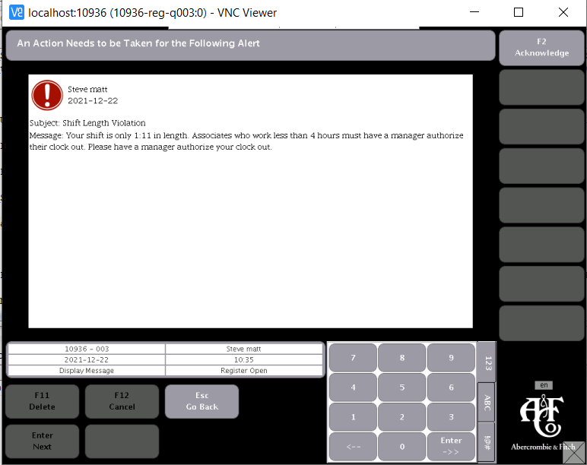

# Short Meal - Minor

An employee attempts to meal in before the designated amount of break minutes have been met.

## Verification: Central Office

SELECT ANF_DC_CNCT FROM PA_EM WHERE ID_EM = 'employee ID' and ID_STR_RT = 'store ID'

Verify ANF_DC_CNCT has DOB that makes the employee not a minor (usually 18 or over)

## Execution:

Punch an employee out for a meal and then wait 5 minutes and punch the employee out

**Expected Result**: Display Message screen displays following message:

**‘MESSAGE’**

# Short Meal - Minor

An employee attempts to meal in before the designated amount of break minutes have been met.

## Verification: Central Office

SELECT ANF_DC_CNCT FROM PA_EM WHERE ID_EM = 'employee ID' and ID_STR_RT = 'store ID'

Verify ANF_DC_CNCT has DOB that makes the employee a minor (usually 17 or under)

## Execution:

Punch an employee out for a meal and then wait 5 minutes and punch the employee out

**Expected Result**: Display Message screen displays following message:

**‘MESSAGE’**

# Confirm Availability

## Set up: Regional’s

DELETE FROM ANF_CLOCK_PUNCH WHERE ID_EM = 'employee ID' and ID_STR_RT = 'store ID'

## Execution:

Clock in employee

**Expected Result:** Display Message screen displays following message:

**‘**Subject: Schedule Availability

Message: Please confirm with your manager your schedule availability for the week ending 2011-04-09. **‘**

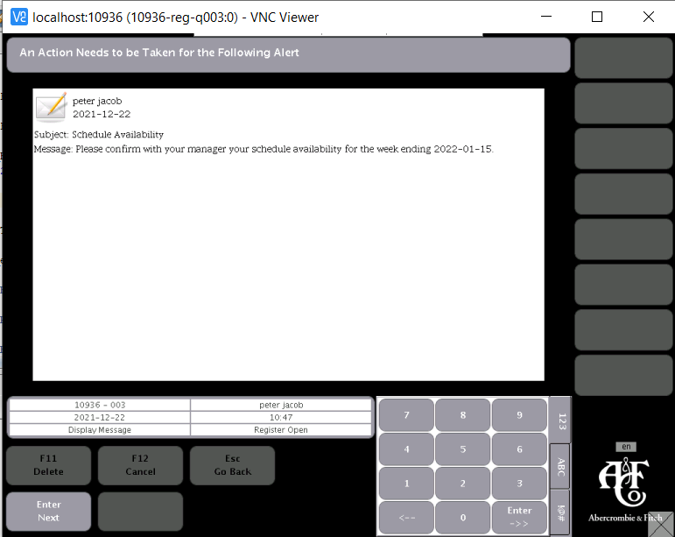

# Early In

An employee clocks in prior to the start of their shift (Note: an employee can clock in 7 minutes prior to the start of their shift without it being an early in)

## Set up: Central Office

INSERT INTO "ANF_SCHEDULE_SHIFT"("ID_EM","ID_STR_RT","WEEK_END_DATE", "DAY_OF_WEEK", "SHIFT_NUMBER", "SHIFT_START_TIME", "SHIFT_END_TIME", "BREAK_START_TIME", "BREAK_END_TIME", "DELETED_TIME", "CREATED_TIME", "LAST_UPDATED_ID", "LAST_UPDATED_TIME", "SHIFT_TYPE") VALUES('employee ID', 'country code', '2011-03-12 00:00:00.00','3','25432','2011-03-08 09:45:00.00','2011-03-08 14:00:00.00', null, null, null, current_timestamp, 'peeps', current_timestamp, 'R');

## Execution:

Clock the employee in 8 or more minutes prior to the start of the schedule shift

**Expected Result:** Display Message screen displays following message:

‘**MESSAGE**’

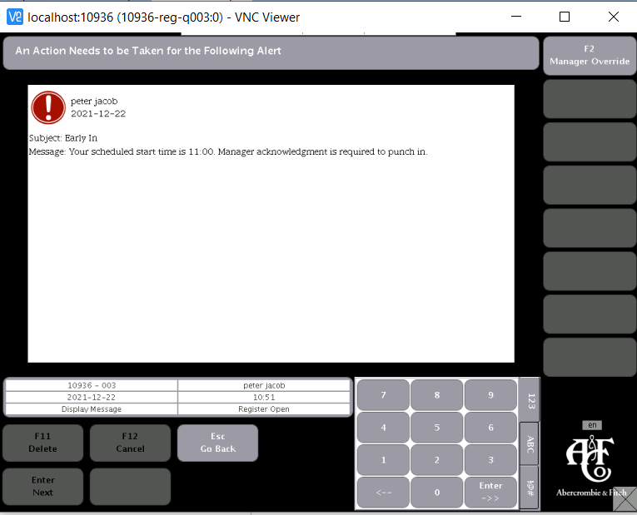

# Incomplete Forms

## Set up: Central Office

UPDATE PA_EM SET FRMS_FLG = '1' WHERE ID_EM = 'employee ID' and ID_STR_RT = 'store ID'

## Execution:

Use employee ID with forms to log into Associate Access

**Expected Result**: Display Message screen displays following message:

**‘**Subject: Forms

Message: You have forms that need completed. **‘**

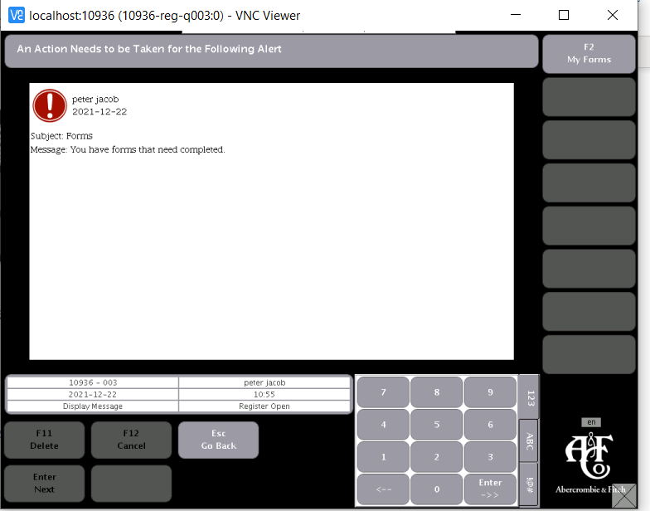

# Late In

An employee clocks in after to the start of their shift (Note: an employee can clock in 7 minutes after the start of their shift without it being an early in)

## Set up: Central Office

INSERT INTO "ANF_SCHEDULE_SHIFT"("ID_EM","ID_STR_RT","WEEK_END_DATE", "DAY_OF_WEEK", "SHIFT_NUMBER", "SHIFT_START_TIME", "SHIFT_END_TIME", "BREAK_START_TIME", "BREAK_END_TIME", "DELETED_TIME", "CREATED_TIME", "LAST_UPDATED_ID", "LAST_UPDATED_TIME", "SHIFT_TYPE") VALUES('employee ID', 'country code', '2011-03-12 00:00:00.00','3','25432','2011-03-08 09:45:00.00','2011-03-08 14:00:00.00', null, null, null, current_timestamp, 'peeps', current_timestamp, 'R');

## Execution:

Clock the employee in 8 - 60 minutes after the scheduled shift start time

**Expected Result:** Display Message screen displays following message:

‘**MESSAGE**’

# No Punch for Scheduled Shift

An employee has a shift scheduled, it is an hour past the scheduled start time, and the employee has not punched in

## Set up: Central Office

INSERT INTO "ANF_SCHEDULE_SHIFT"("ID_EM","ID_STR_RT","WEEK_END_DATE", "DAY_OF_WEEK", "SHIFT_NUMBER", "SHIFT_START_TIME", "SHIFT_END_TIME", "BREAK_START_TIME", "BREAK_END_TIME", "DELETED_TIME", "CREATED_TIME", "LAST_UPDATED_ID", "LAST_UPDATED_TIME", "SHIFT_TYPE") VALUES('employee ID', 'country code', '2011-03-12 00:00:00.00','3','25432','2011-03-08 09:45:00.00','2011-03-08 14:00:00.00','2011-03-12 10:30:00.00','2011-03-12 11:00:00.00', null, current_timestamp, 'peeps', current_timestamp, 'R');

## Set up: Regional’s

DELETE * FROM ANF_CLOCK_PUNCH WHERE ID_EM = ‘employee ID’

## Execution:

60 minutes past the shift start time, log into associate access (not with employee ID for shift scheduled)

**Expected Result**: Display Message screen displays following message:

**‘**Subject: No Punch in

Message:Kohei Sato has not punched in for his/her scheduled shift: 08:45 – 18:00. Please indicate the appropriate reason for the absence.**’**

# Meal Scheduled

An employee punches in and they have not schedules meal

## Set up: Central Office

INSERT INTO "ANF_SCHEDULE_SHIFT"("ID_EM","ID_STR_RT","WEEK_END_DATE", "DAY_OF_WEEK", "SHIFT_NUMBER", "SHIFT_START_TIME", "SHIFT_END_TIME", "BREAK_START_TIME", "BREAK_END_TIME", "DELETED_TIME", "CREATED_TIME", "LAST_UPDATED_ID", "LAST_UPDATED_TIME", "SHIFT_TYPE") VALUES('employee ID', 'country code', '2011-03-12 00:00:00.00','3','25432','2011-03-08 09:45:00.00','2011-03-08 14:00:00.00','2011-03-12 10:30:00.00','2011-03-12 11:00:00.00', null, current_timestamp, 'peeps', current_timestamp, 'R');

## Set up: Regional’s

DELETE * FROM ANF_CLOCK_PUNCH WHERE ID_EM = ‘employee ID’

## Execution:

Clock the employee in

**Expected Result**: Display Message screen displays following message:

**‘MESSAGE’**

# Not Scheduled to Work

## Set up: Regional’s

DELETE FROM ANF_CLOCK_PUNCH WHERE ID_EM = 'employee ID' and ID_STR_RT = 'store ID'

## Execution:

Clock in employee

**Expected Result:** Display Message screen displays following message:

**‘**Subject: Not Scheduled

Message: You are not currently scheduled to work. Please select the reason for working while not scheduled.**‘**

# Shift End

An employee’s shift has expired by 60 minutes or greater and they have not punched out

## Set up: Central Office

INSERT INTO "ANF_SCHEDULE_SHIFT"("ID_EM","ID_STR_RT","WEEK_END_DATE", "DAY_OF_WEEK", "SHIFT_NUMBER", "SHIFT_START_TIME", "SHIFT_END_TIME", "BREAK_START_TIME", "BREAK_END_TIME", "DELETED_TIME", "CREATED_TIME", "LAST_UPDATED_ID", "LAST_UPDATED_TIME", "SHIFT_TYPE") VALUES('employee ID', 'country code', '2011-03-12 00:00:00.00','3','25432','2011-03-08 09:45:00.00','2011-03-08 14:00:00.00', null, null, null, current_timestamp, 'peeps', current_timestamp, 'R');

**Note**: you can make the shift start time for a time in the past and just adjust the clock punch time in the local DB after you punch the employee in

## Set up: H2 Database

After clocking in the employee:

SELECT * FROM ANF_CLOCK_PUNCH WHERE ID_EM = ‘employee ID’

Change the employee punch in time to correspond with the shift start time and restart iPOS

## Execution:

60 minutes after the scheduled shift had ended, log into the associate access

**Expected Result**: Display Message screen displays following message:

**‘**Subject: Shift End

Message: Associate Kohei Sato has not punched out for the scheduled shift from 07:00 – 19:00**’**